|  |
| --- |
| A close up of a chocolate bar |
| Chocolate Sales Analysis |
| |  |  |  | | --- | --- | --- | | Early, Torry | 04/01/25 | Market Analysis | |

Table of Contents

**Executive Summary**

**Section 1 : Product analysis**

**Section 2: Country analysis**

**Section 3: Insights and Recommendations**

Executive Summary

This report analyzes chocolate sales from many online retailers and marketplaces. These sales come from six different countries: Australia, Canada, India, New Zealand, UK, and the USA. The goal of the report is to identify key trends and optimize sales and marketing opportunities.

**Product Analysis**

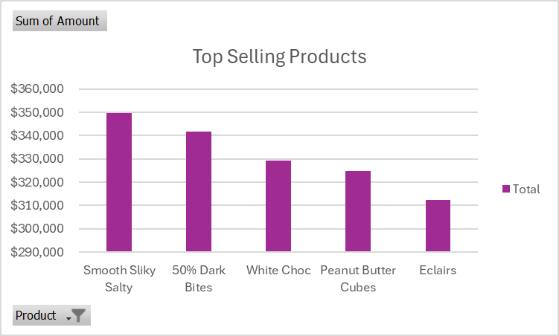

**COUNTRY SALES ANAYLSIS : AUSTRALIA**

|  |  |  |  |
| --- | --- | --- | --- |
| Top Products | $Amount Sold | % of Sales | Average Price |
| 50% Dark Bites | 89,222 | 7.84 | 5,576 |
| Eclairs | 64,323 | 5.66 | 6,432 |
| Milk Bars | 61,173 | 5.38 | 5,561 |